**The main difference between a Replica Set and a Replication Controller right now is the selector support.**

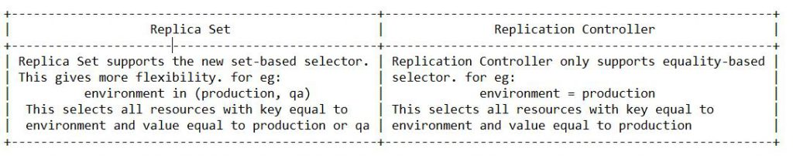

**The second thing is the updating the pods**

